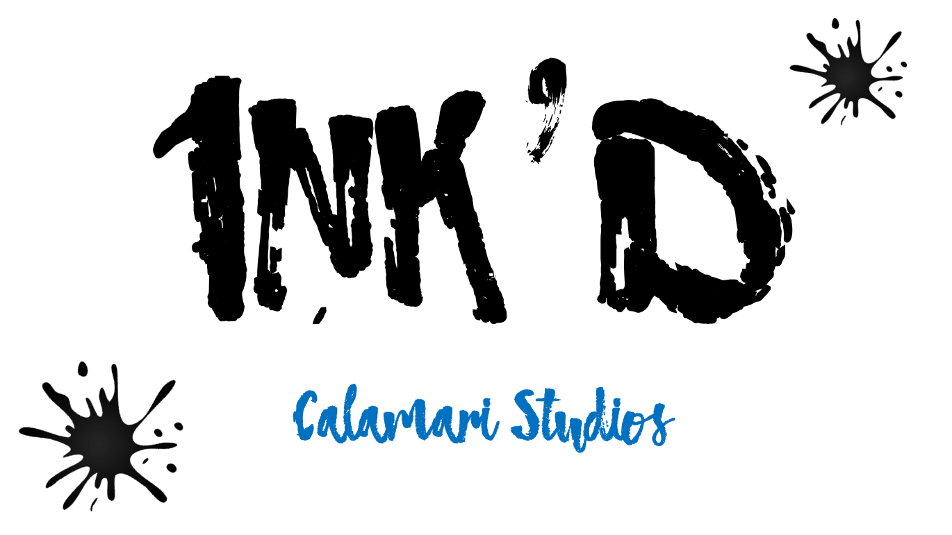
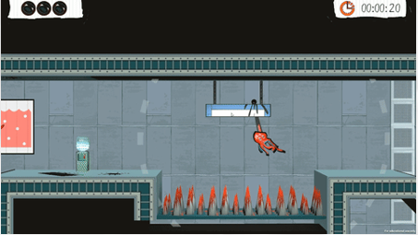
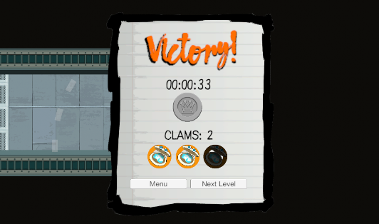
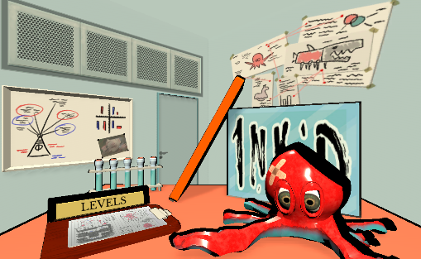




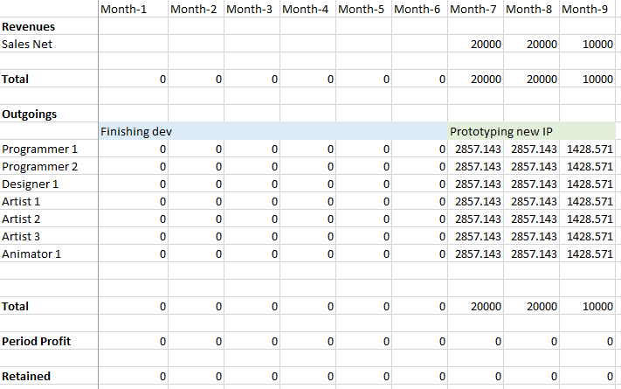
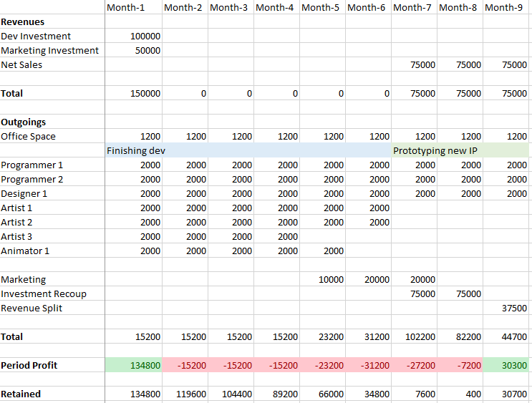
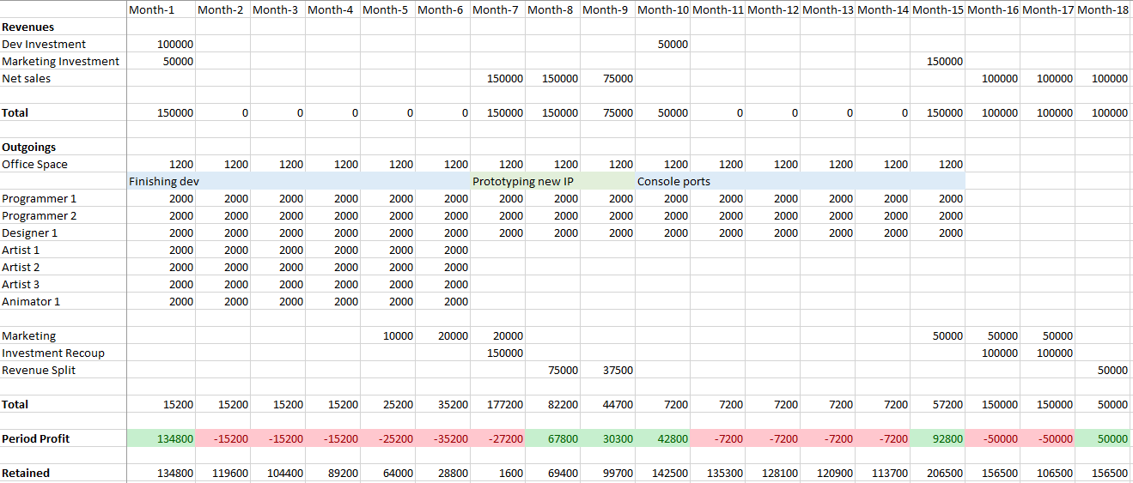
Business Report

Executive Summary

Market Evaluation
Game Value
INK’D is a casual game created by Calamari Studios. It is designed to be played on PC currently with the intention of porting to mobile, Android and IOS, in the future.
The game brings a new and unqiue movement system that makes it stand out from other games avaliable on the market. This movement system drives many fun and interesting gameplay scenarios. Each level the player is tasked with controlling two octopus arms to fling their way towards the exit. The art style of the game takes inspiration from classic Saturday morning cartoons with colourful main objects and a more muted hand painted style for the backgrounds, helping appeal to the target market. The game features an ongoing story that is told via cutscenes between certain levels and through the mriad of NPC friends the player talks to throughout the levels.
The game has been designed to appeal to casual gamers, gamers interested in experencing unquie gameplay and completionists looking for a low time investment completion game. The game consists of 24 levels, 5 levels and 1 boss level for each world, these worlds all have a different colour style to aid in the feeling of progression. Each level has 3 clams to be collected, and also medals given for completion time. The results the player recieves for these are persitant allowing players to come back and try to improve on their scores. An additional medal is tied to collecting all clams and getting the best time in one run. This special medals unlock special gallery images and even a secret playground level. All of these combined add a ton of replayabilty for the game while still allowing short bursts of gameplay with a feeling of progression.

Marketing Personas
In regards to Bartle Player types (cite) INK'D is being created to target the achiever type, for this the game provides medals what the players can unlock on each level with varying difficulty. The other type this game targets is the explorer type, clams are hidden around the levels in sections that would otherwise not be needed to visit, creating additional back tracking with locked doors to access some areas.
The game has been designed to fit with players that have a low amount of time available to play, there is still however scope for a player to burst through the game in quick succession. For this reason the levels are short, it is expected that no level will take longer than 1 minute to attempt to complete. It is unexpected that players will get all collectables and the time medals during the first play of a level, making these levels interesting to retry.
Generally the majority of players will match the personas below of Belinda and Barry which matches with our focus on short gameplay bursts with superficial rewards for those levels. We expect to have a few players like Jordan so we have provided challenging platinum medals for getting all clams and the time medal in one run, making sure those players will have a good amount of challenge to collect everything. Finally we have Claire, our interesting movement system that can reward the player with incredible fluidity and speed will match with her speed running ideals.

Jordan | Role: Completionist Indie Gamer
Description
Plays plenty of new indie games, has a lot of time on his hands after work and gets life satisfaction from completing everything a game has to offer.
Quote
You’re not really finishing a game unless you’ve unlocked everything it has to offer.
My favourite collectable has to be the assassin’s creed feathers.
User Goals
Will play the game until they unlock everything.

Belinda | Role: Office worker
Description
Works really hard and just needs a little break at lunch to wind down. Usually plays mobile games but has started using her PC for the bigger screen.
Quote
It’s so much fun to play a game for 5 minutes on my break, I like colourful games.
User Goals
Short bursts of gameplay being able to complete a level quickly

Claire | Role:
Description
speed runner
 | Quote
 | User Goals

Barry | Role: College Student
Description
Spends his day at college and evening doing his homework, manages to take some time to play casual games every now and again so long as his work is done first.
Quote
There’s nothings better than getting straight A’s, but my second favourite thing is getting an early night.
User Goals
Have a quick bit of wholesome fun.

Routes to market
Self-Publishing

Sales Channels
Advertising
Further Work
Revenue Forecast

Publisher
Market Position
Advertising
Revenue Model
Revenue Forecast

Development Plan
Self-Publishing
Cash Flow Forecast

Publisher
Cash Flow Forecast (Min estimated sales)
Cash Flow Forecast (Max estimated sales)

Conclusions
Assumptions and Risks
Accuracy of publisher information

Recommendations

Useful references:
https://docs.google.com/document/d/11m25Ih7WZ5A5qVJpqAYKHN84F78AlC4ANUMmifzg-IA/edit#heading=h.r4ub948mvzaf
https://docs.google.com/document/d/1SxKxVi4smDy-guH56wPtDa2VzDF9TJ44HXgtBZai1ao/edit
https://files.slack.com/files-pri/TD2EBM695-FDF945BSA/download/market_research_essay_final.docx

